Part A

For part A, as we can see in the question request, it said we need to move and rotate the camera follow the action of the left and middle button on the mouse.

Looking through the lecture 14 p8, we get this picture:

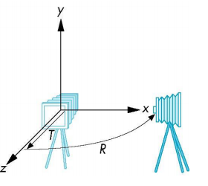

So it means we need to rotate the camera on the x and y axis.

Here are some pictures to make more sense:

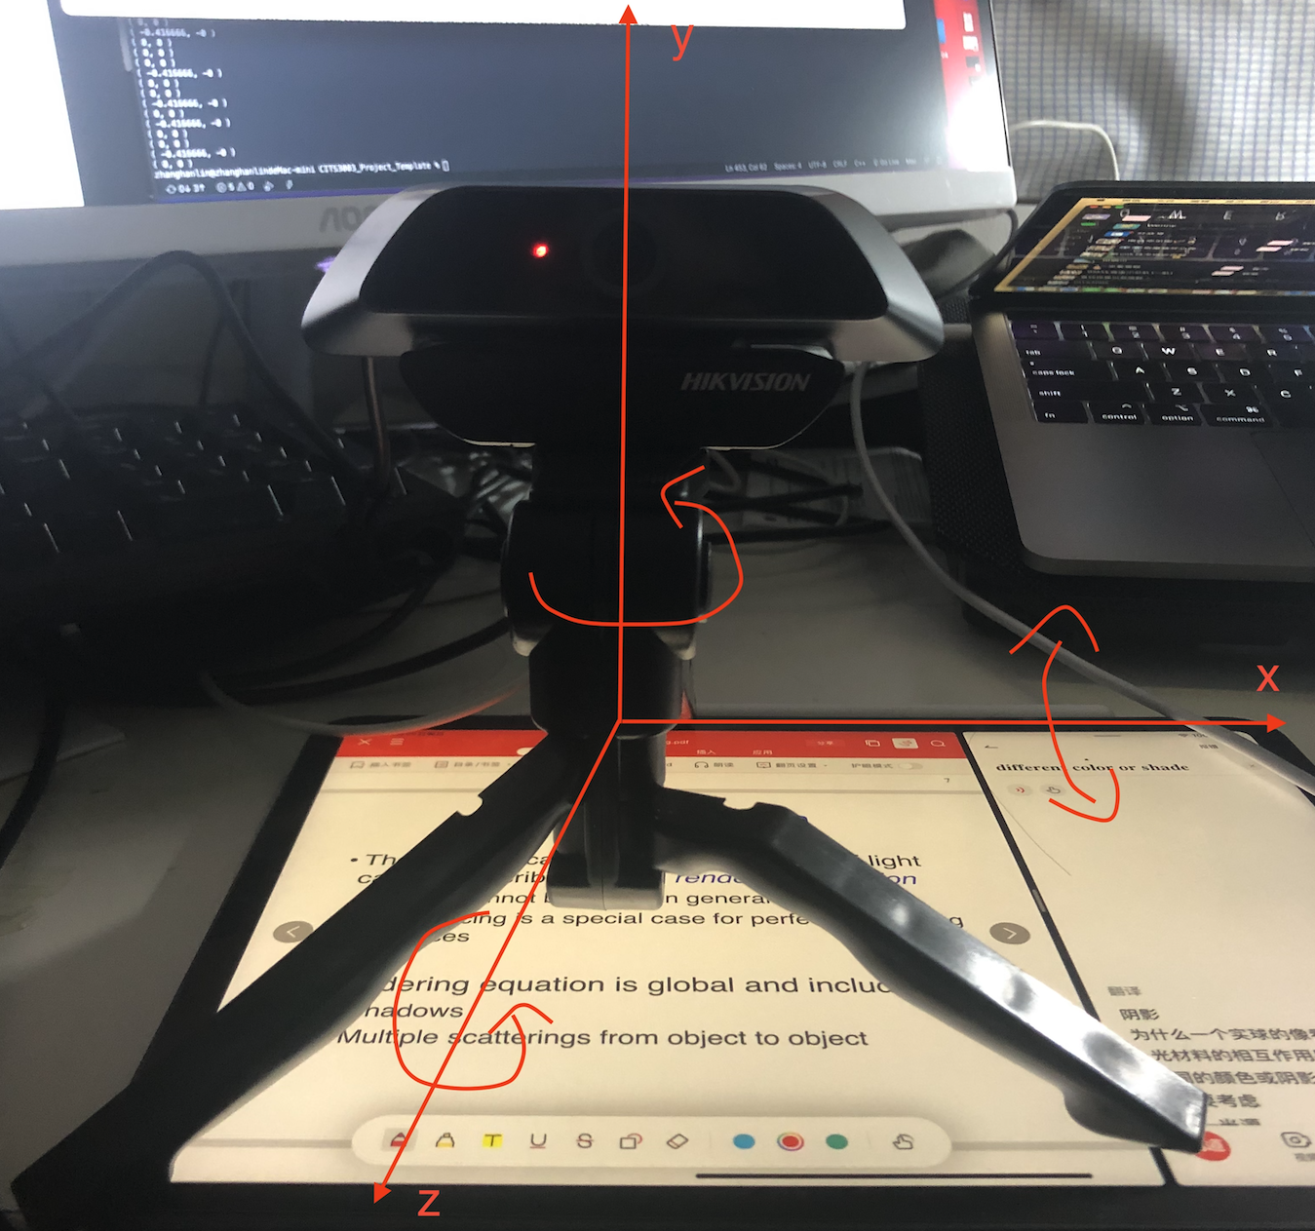

Rotate X:

The camera rotate on x-axis if you compare with the origin picture

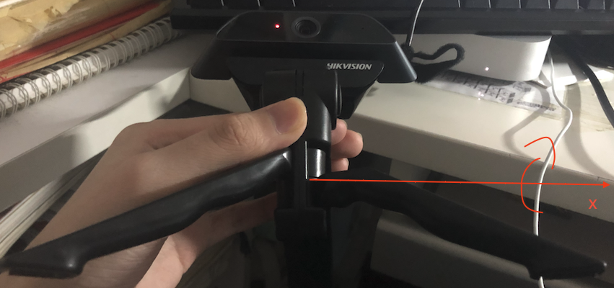

Rotate Y:

The camera rotate on y-axis if you compare with the origin picture

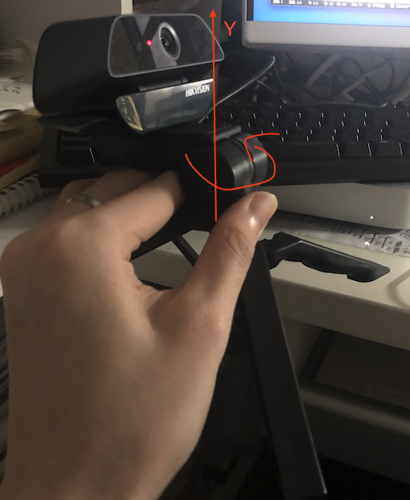

Rotate Z:

The camera rotate on z-axis if you compare with the origin picture

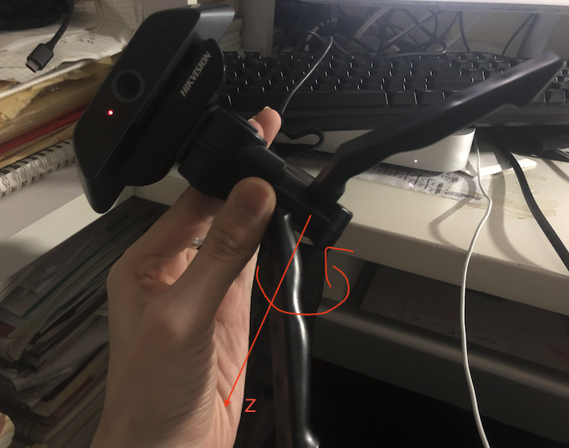



Also, from the lecture 14, we learn a formula at p8:

Since we need to rotate an x-axis and y-axis, so we get the code below:



Part B

Similar to part A, but this time we need to change the angle of the object (rotate the object).

Original object:

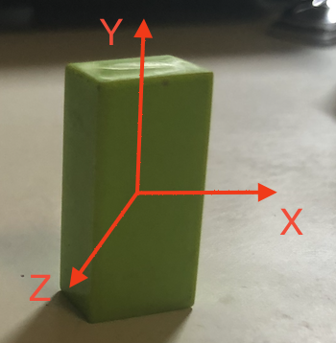

Rotate X:

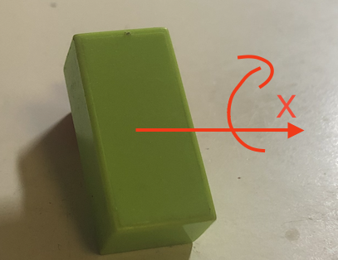

Rotate Y:

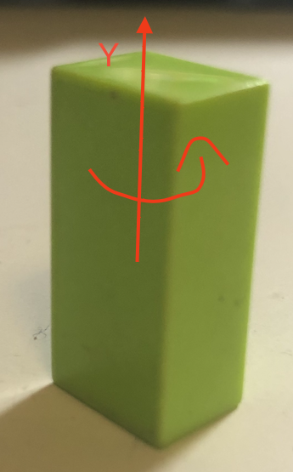

Rotate Z:

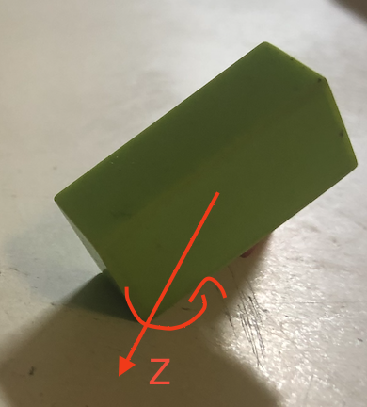

So in this part, we need to consider all of the situations, rotate x-axis, y-axis, z-axis.

As we know, inside of the structure “SceneObject”, it contains a float list named angles which contains the rotations around X,Y and Z axes.

Finally, based on the last part and the information we get from this part, we get code below:



Part C

Same with what we know from the question request, it ask us to modify the function below:

